Jira Assignment

Name : Kishor Kumar

Jira Login

List of Issues in JIRA

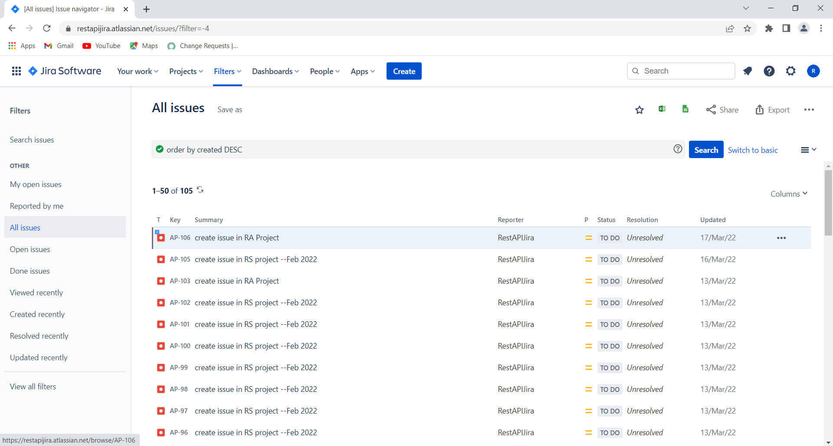

Postman Login

Created New Collection for Jira

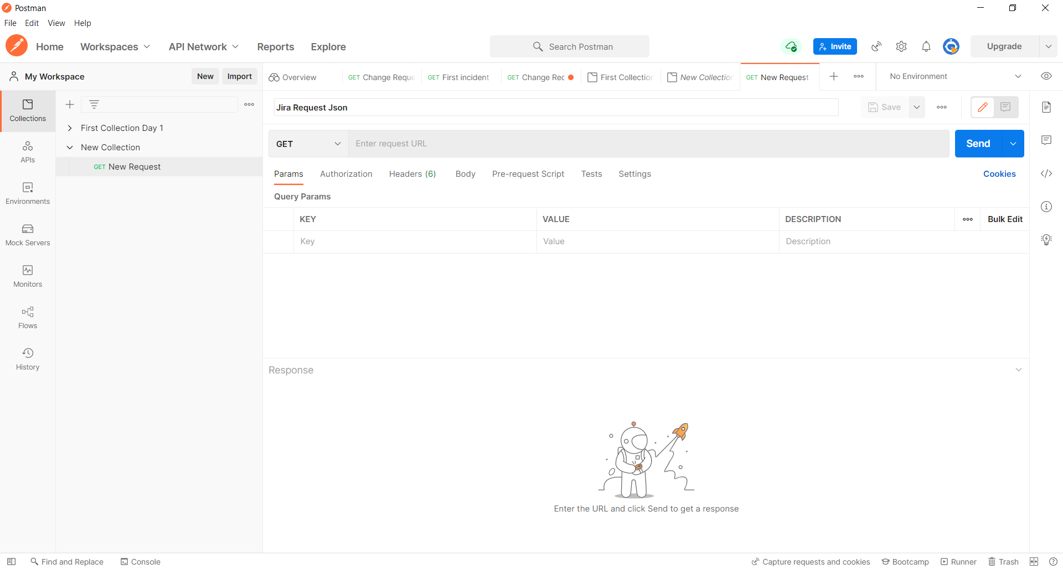

Using below End point to List all issue types

End Point: [https://restapijira.atlassian.net/rest/api/2/search?jql=project="AP](https://restapijira.atlassian.net/rest/api/2/search?jql=project=%22AP)"

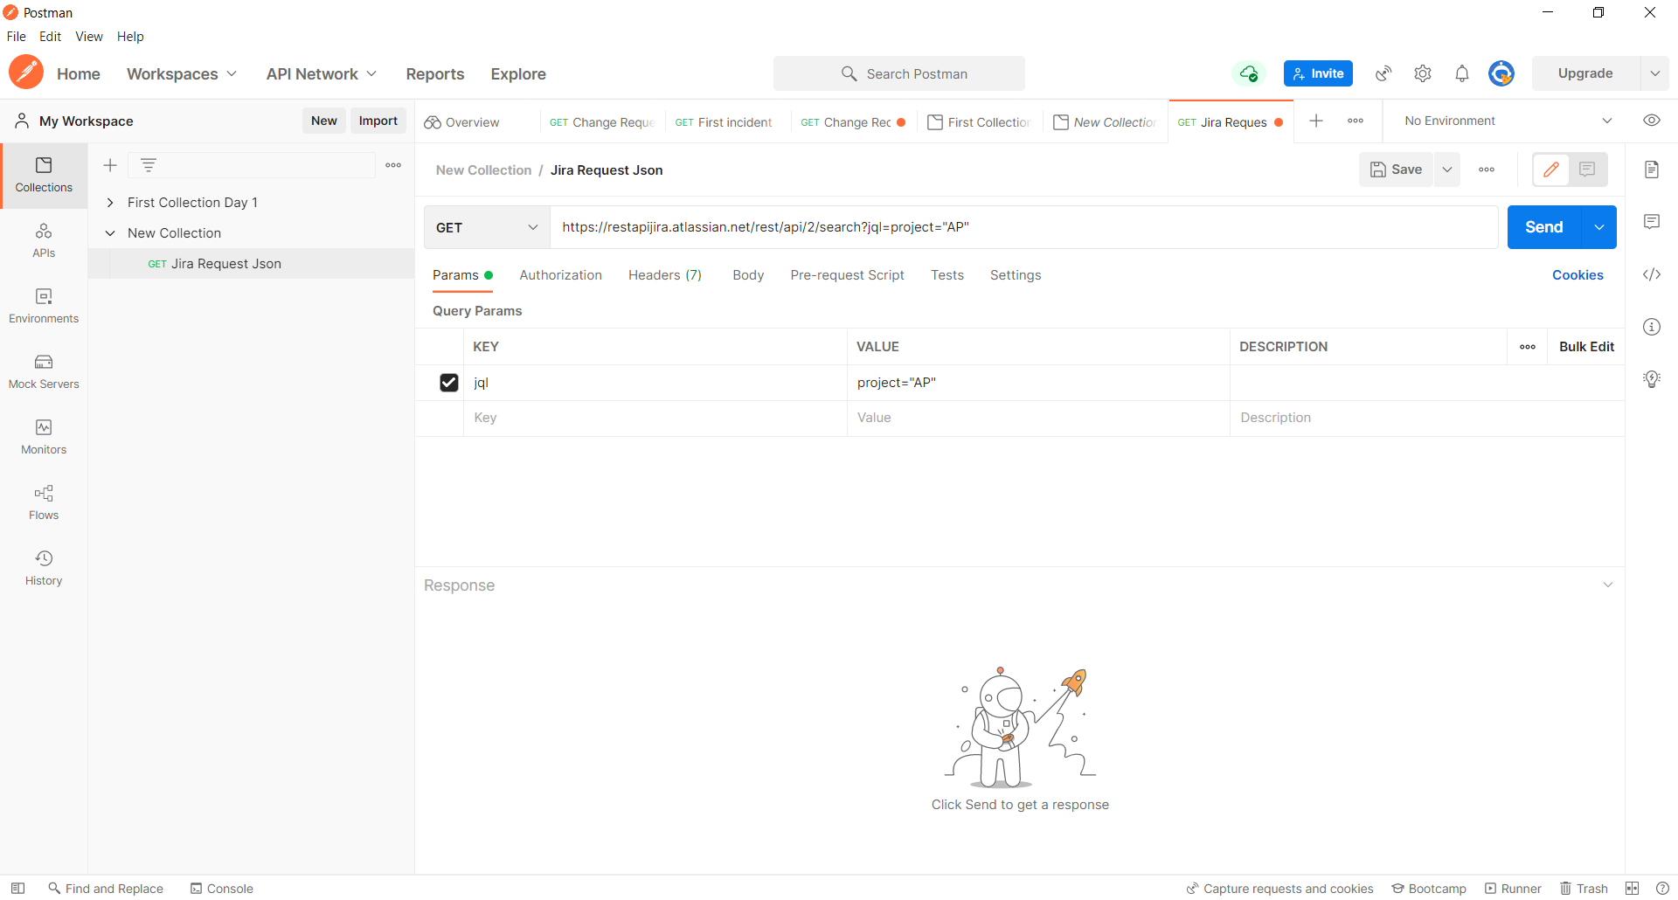

**Authorization**

Provided Basic Auth in Authorization

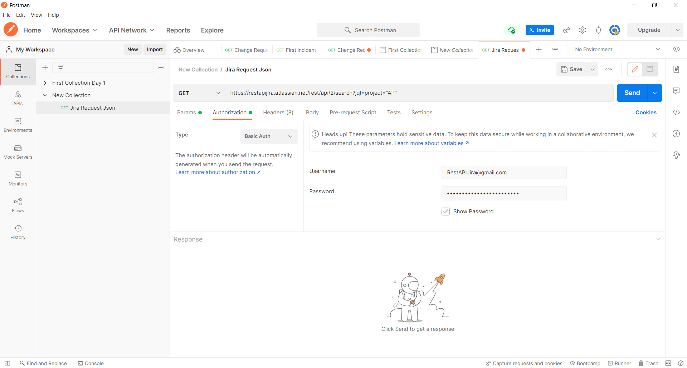

Header

Provided Header as Accept

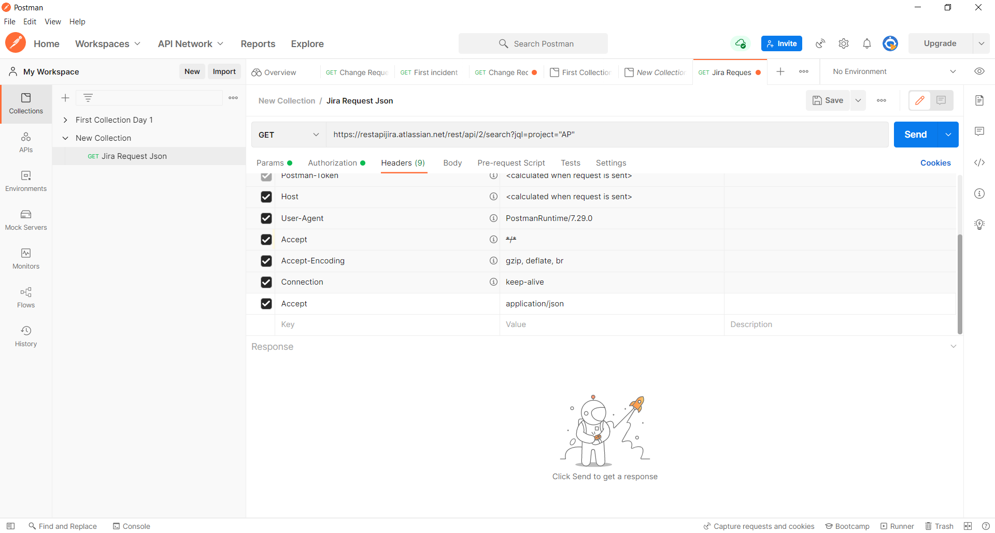

Clicked Send

All 105 issues are getting displayed as Expected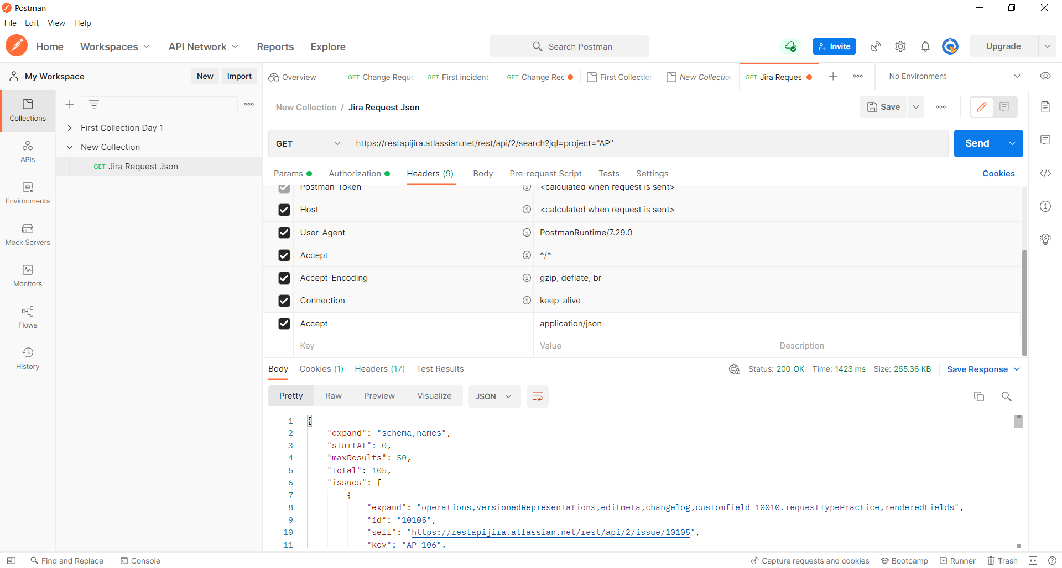



Getting All Issues that has been created with in 24 Hours

Key – jql

Value – project=AP%26created>=-24h

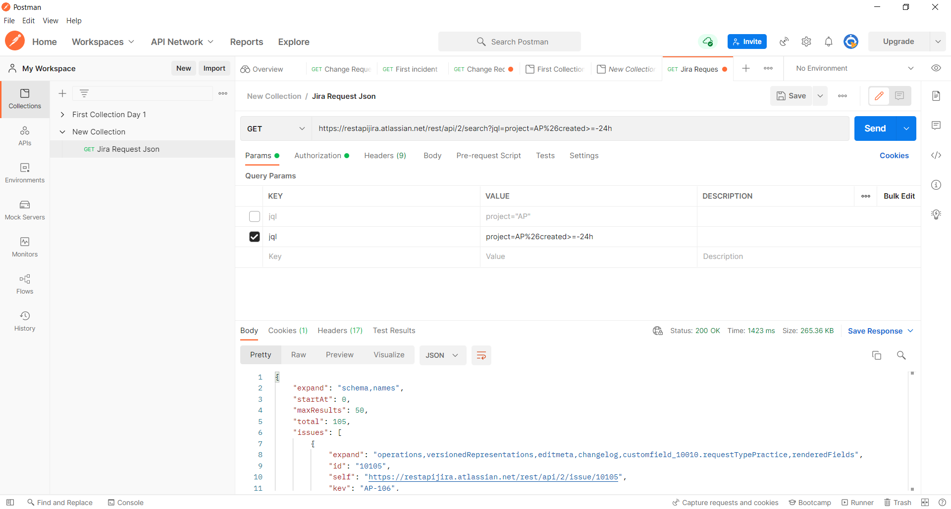

Clicked Send